CHAPTER 1
INTRODUCTION
The project titled “ONLINE DISCUSS FORUM” is designed using Active Server Pages .NET and SQL Server 2005 which runs under .Net Frame Work 2008 in Microsoft Windows Operating System family.

The project contains seven main modules.
- Category
- Post Question
- Registration
- Answer
- Discover
- Articles
- Search

- Category Module:
This module is the main module, by selecting the category user can post their questions easily. They can retrieve the answers for their questions from the different users.

2. Post Question Module:
This module is mainly for the registered users. As the Administrator has to know who has posted the questions the user is registered here. These registered users alone can post their question in detailed manner.

3. Registration Module:
This Module helps to give the detailed information about the newly entered user.

4. Answer Module:
Each and every posted question will get the exact answer from the Discussion Forum team and also they can get a lot of answers from the different user.

5. Discover Module:
Users can answer the questions which are posted in this site. Both registered and non registered user is benefited over this module. They can also view the answers posted in this site.

6. Articles Module:
User can post their invention and also they can know about the ideas of the all Users.

7. Search Module:

This module is used to search their queries , the articles and also the inventions. Both registered and non registered users can search over here

CHAPTER 2

SOFTWARE PROJECT PLAN

This chapter discuss about that time schedule for the project and it contain the various phases of the project
.
The Various Phases of the Project:

S.NO | TASK | DURATION
1 | Requirement Specification | 10 Day’s
2 | Requirement document specification | 10 Day’s
3 | Design analysis | 20 Day’s
4 | Design Documentation | 15 Day’s
5 | Design Review | 20 Day’s
6 | Coding | 15 Day’s
 | Total | 90 Day’s

CHAPTER 3

CUSTOMER REQUIREMENTS DETERMINATION

3.1 Existing System

In general people share their ideas, queries and answers from their colleagues or friends through the intercom or direct manner. They need to spend time for their work.

Drawbacks

Some of the drawbacks are:
1. Details are enquired through phone.
2. It consumes more time
3. They don’t get proper answers.

3.2 Proposed System

It is difficult to note down all the problems manually. Instead it is decided to develop an “ONLINE DISCUSS FORUM” to ease the operation.

A system is required which is being capable of elimination all the problems and become useful to users and thus the new system is derived. Here we get a different view from different users.

Benefits

- Interaction will be easier.
- Users articles can be viewed by others
- Less time consuming.

CHAPTER 4

SOFTWARE REQUIREMENTS SPECIFICATION

Software Requirements Specification (SRS) is the starting point of the software development activity. Little importance was given to this phases in the early days of software development. The emphasis was first on coding and then shifted to design.
As systems grew more complex, it become evident that the goal of the entire system cannot be easily comprehended. Hence need for the requirements analysis phase arose. Now, for large software systems, requirements analysis is perhaps the most difficult activity and also the most error prone.

Some of the difficulty is due to the scope of this phase. The software project is imitated by the client needs. In the beginning these needs are in the minds of various people in the client organization. The requirement analyst has to identify the requirements by tacking to these people and understanding there needs. In situations where the software is to automated a currently manuals process, most of the needs can be understood by observing the current practice.

The SRS is a means of translating the ideas in the minds of the clients (the output) into formal document (the output of the requirements phase). Thus the output of the phase is a set of formally specified requirements, which hopefully are complete and consistent, while the input has none of these properties.

4.1 Functional Requirements

Profile
Registration
tution
exam
Library
others
View Profile
New User
Search
Post Question
View Question
Post Article
Article
View article

ADMIN
Post Question

4.2 Performance Requirements
The project must the end user requirements. Accuracy and fast must be imposed in the project.
The project is development as easy as possible for the sake of end user. The project has to be developed with view of satisfying the future requirements and future enhancement.
This processing as well as tine taken to generate well reports where also even when large amount of data was used. The system is designed in such a way that even when large amount of data used for processing there would less performance degradation.

4.3 Interface requirements
4.3.1 Hardware Interface
The stranded input device like keyboard and mouse are to get input. The output will be generated and display in the monitor. The reports can also be exported to a SQL-server document are text file. The stranded printer in used to take outputs.

4.3.2 Software Interface
The design part and interface id done the front end ASP.Net and SQL server as a backend of the project.

4.4 Operational requirements
The database or databases that are being failed over to the stand by server cannot be used for anything else.but databases on the standby server not being used for failover can still be used normally.

When it comes time for actual failover,you much one of two things to make your application work either rename the standby server the same name as the failed production server(and the IP address),or re-point your user’s applications to new standby server.in some cases,neither of this option is practical.

4.5 Resource Requirements

4.5.1 Hardware Requirements

PROCESSOR : PENTIUM III 866 MHz
RAM : 128 MD SD RAM
MONITOR : 15” COLOR
HARD DISK : 20 GB
FLOPPY DRIVE : 1.44 MB
CD DRIVE : LG 52X
KEYBOARD : STANDARD 102 KEYS
MOUSE : 3 BUTTONS

4.5.2 Software Requirements

OPERATING SYSTEM : Windows XP Professional
ENVIRONMENT : Visual Studio .NET 2003
.NET FRAMEWORK : Version 1.1
LANGUAGE : C#.NET
WEB TECHNOLOGY : ASP.NET
BACKEND : SQL SERVER 2000

4.6 Security Requirements
Web application are available via network access, it is a difficult. If not possible, to limit the populatin of the end-user who may access the applications? In order to product sensitive connect and provide secure mode be implemented throughout the infrastructure that the supports web application and within the application itself.
Web Application have become heavy integrated with critical corporate and database. E-commerce application extracts and then store sensitive customer information.
.
4.7 Design Requirements
To create project, add base masters and masters to the project, assign behaviors to the master, create and assign behavior sets, and then apply, test and validate those behaviors. It also shows how to create and build a stencil to hold the shapes.

4.8 Quality and Reliability Requirements
A software component that is developed for reuse would be correct and would contain no defects. In reality, formal verification is not carried out routinely, and defects can add to occur.However,with each reuse,,defects are found eliminated, and a components qualify improve as a result. Over time the components virtually defect free.
Software reliability is defined in statical term as” the probability of faultier-free operation of a computer program in a specified environment for specified tine”. The software quality and reliability ,failure is nonconformance to software requirements.

Web Correct link processing
Application Reliability Error recovery
Quality Input validation and recovery
CHAPTER 5

SYSTEM ANALYSIS

In this section discussed about data flow diagram, Entity relationship diagram. These things are represented as diagrams with proper notation.

5.1 Data Flow Diagram

The data flow diagram is one of the most improvement tools used by the system analyst DeMacro (1978) Nad Gand Sarson (1979) popularized the use if the data flow diagram as modeling tools through their structured system analysis methodologies.
A data flow diagram should be the first tool used by system analyst to model system components. These components are the system processes; the data used by this processes and external entities that interact with the system and the information flows in the system.

5.1.1. Process

Process show what system does. Each process has one or more data inputs and produce one or more data output, Circles in a data flow diagram represent process. Each process has unique name and number. This name and number appear inside the circle that represents the processes in a data flow diagram.

This process is represented as circle

5.1.2. Data Stores:

File or data store is depositary of data. They contain data that is retained in the system. Processes can enter the data into a data store or retrieve data from the data store. Each data store is represented by thin line in the data flow diagram and each data store has a unique name.
The data store is represented in form of a line

5.1.2 External Entities:

External entities are outside the system but they either supply input data into the system or use the system output, they are entities which the designer has no control. Square or rectangle may represent external entities that supply data into a system or some times called sources. External entities that use the system data are sometimes called sinks.

5.1.4 Data Flows:

Dataflow model the passage of data in the system and are represented lines joining system components. An arrow indicates the direction of the flow and the line labeled by the name of the data flow.

DATA FLOW DIAGRAM

Registration
Module
Registration master
UserName
Password
ContactAddress
Email Id
CompanyName
Security Question
Security Answer

UserImage

Category Module

Category
Module
Category id
Name
Category master

Post Question

Question
Module
Question
Username
Category Id
Key Id
Date
Question
Question Desc.

Answer

Answer
Module
Answer
Username
Question Id
Access Date
Answers
User Image
Email_id

Keyword

Key
Key master
Keyword

Article
Category Id

Article Subject

Link

Article
Module
Article
Key Id
Content

View Question
View Answers
View Attachments
Admin
Admin Table
Question Table
Answers Table
Attachment
Table

Level_1
Admin

Question
Question
Login
Answer
Login
User
Registration Table
Question Table
Login Table
User
Registration Table
Answer Table
Login Table

Answer

5.2 ER DIAGRAM

Profile
View Profile
New User
Post Question
View Question
Post Article

ADMIN
View article
tution
exam
Library
others
Registration
Search
Article
Post Question

5.3 Use Case Diagram

Identifying Excisting Customer
Create New Account
Post Online Question
View Question

Answer the Question
Discover the details

Upgrade details

5.4 Software Life Cycle
Title Submission
Authorization Certificate
Students
Training
Problem Analysis:
Online Discuss-Forum
Front-end Asp.net
Back-end: SQL Server
Code behind: C#.net
Networking Design:
Internet Explorer 6.0
Coding
Validation
Testing
Document
Reports
Certificate
Complete Certificate
Programmer Training Certificate
Authorization Signatory
Learning Process
DB
CHAPTER 6
SYSTEM DESIGN

Design is multi-step process that focuses on data structure software architecture, procedural details, (algorithms etc.) and interface between modules. The design process also translates the requirements into the presentation of software that can be accessed for quality before coding begins.
Computer software design changes continuously as new methods; better analysis and broader understanding evolved. Software Design is at relatively early stage in its revolution.
Therefore, Software Design methodology lacks the depth, flexibility and quantitative nature that are normally associated with more classical engineering disciplines. However techniques for software designs do exist, criteria for design qualities are available and design notation can be applied.

6.1 Input Design

Input design is the process of converting user-originated inputs to a computer-based format. Input design is one of the most expensive phases of the operation of computerized system and is often the major problem of a system.
In the project, the input design is made in various web forms with various methods.
6.2 Output Design

Output design generally refers to the results and information that are generated by the system for many end-users; output is the main reason for developing the system and the basis on which they evaluate the usefulness of the application
In the project, once question are posted, It stores in to the data base. The questions are viewed and also the user who needs the details about the question can register and see the related answer which is to be posted this sit

6.3 Interface Design
The ODBC (Open Database Connectivity) interface is a pure .NET to execute SQl statement. The ODBC provides a set classes and interfaces that can be used by developers to write database applications. Basic ODBC interactions in its simplest form, can be broken down into four steps:

1. Open a connection to the database.
2. Execute a SQL statement
3. Process the result
4. Close the connection to the database
Database Design

The database design is a must for any application developed especially more for the data store projects. Since the chatting method involves storing the message in the table and produced to the sender and receiver, proper handling of the table is a must.

In the project, login table is designed to be unique in accepting the username and the length of the username and password should be greater than zero.

The complete listing of the tables and their fields are provided in the annexure under the title ‘Table Structure’.

The .Net Framework

The .NET Framework is a new computing platform that simplifies application development in the highly distributed environment of the Internet.

Objectives of. Net framework:
1. To provide a consistent object-oriented programming environment whether object codes is stored and executed locally on Internet-distributed, or executed remotely.

2. To provide a code-execution environment to minimizes software deployment and guarantees safe execution of code.

3. Eliminates the performance problems.

There are different types of application, such as Windows-based applications and Web-based applications.

To make communication on distributed environment to ensure that code be accessed by the .NET Framework can integrate with any other code.

Components Of .Net Framework

1. The Common Language Runtime (CLR):
The common language runtime is the foundation of the .NET Framework. It manages code at execution time, providing important services such as memory management, thread management, and remoting and also ensures more security and robustness. The concept of code management is a fundamental principle of the runtime. Code that targets the runtime is known as managed code, while code that does not target the runtime is known as unmanaged code.

The .Net Frame Work Class Library:
It is a comprehensive, object-oriented collection of reusable types used to develop applications ranging from traditional command-line or graphical user interface (GUI) applications to applications based on the latest innovations provided by ASP.NET, such as Web Forms and XML Web services.

The .NET Framework can be hosted by unmanaged components that load the common language runtime into their processes and initiate the execution of managed code, thereby creating a software environment that can exploit both managed and unmanaged features. The .NET Framework not only provides several runtime hosts, but also supports the development of third-party runtime hosts.

Internet Explorer is an example of an unmanaged application that hosts the runtime (in the form of a MIME type extension). Using Internet Explorer to host the runtime to enables embeds managed components or Windows Forms controls in HTML documents.

FEATURES OF THE COMMON LANGUAGE RUNTIME:
The common language runtime manages memory; thread execution, code execution, code safety verification, compilation, and other system services these are all run on CLR.
Security.
Robustness.
Productivity.
Performance.
Security:
The runtime enforces code access security. The security features of the runtime thus enable legitimate Internet-deployed software to be exceptionally feature rich. With regards to security, managed components are awarded varying degrees of trust, depending on a number of factors that include their origin to perform file-access operations, registry-access operations, or other sensitive functions.

ROBUSTNESS:
The runtime also enforces code robustness by implementing a strict type- and code-verification infrastructure called the common type system(CTS). The CTS ensures that all managed code is self-describing. The managed environment of the runtime eliminates many common software issues.

PRODUCTIVITY:
The runtime also accelerates developer productivity. For example, programmers can write applications in their development language of choice, yet take full advantage of the runtime, the class library, and components written in other languages by other developers.

PERFORMANCE:

The runtime is designed to enhance performance. Although the common language runtime provides many standard runtime services, managed code is never interpreted. A feature called just-in-time (JIT) compiling enables all managed code to run in the native machine language of the system on which it is executing. Finally, the runtime can be hosted by high-performance, server-side applications, such as Microsoft® SQL Server™ and Internet Information Services (IIS).
FEATURES OF ASP.NET

ASP.NET

ASP.NET is the next version of Active Server Pages (ASP); it is a unified Web development platform that provides the services necessary for developers to build enterprise-class Web applications. While ASP.NET is largely syntax compatible, it also provides a new programming model and infrastructure for more secure, scalable, and stable applications.
ASP.NET is a compiled, NET-based environment, we can author applications in any .NET compatible language, including Visual Basic .NET, C#, and JScript .NET. Additionally, the entire .NET Framework is available to any ASP.NET application. Developers can easily access the benefits of these technologies, which include the managed common language runtime environment (CLR), type safety, inheritance, and so on.

ASP.NET has been designed to work seamlessly with WYSIWYG HTML editors and other programming tools, including Microsoft Visual Studio .NET. Not only does this make Web development easier, but it also provides all the benefits that these tools have to offer, including a GUI that developers can use to drop server controls onto a Web page and fully integrated debugging support.

Developers can choose from the following two features when creating an ASP.NET application. Web Forms and Web services, or combine these in any way they see fit. Each is supported by the same infrastructure that allows you to use authentication schemes, cache frequently used data, or customize your application's configuration, to name only a few possibilities. Web Forms allows us to build powerful forms-based Web pages. When building these pages, we can use ASP.NET server controls to create common UI elements, and program them for common tasks. These controls allow we to rapidly build a Web Form out of reusable built-in or custom components, simplifying the code of a page.

An XML Web service provides the means to access server functionality remotely. Using Web services, businesses can expose programmatic interfaces to their data or business logic, which in turn can be obtained and manipulated by client and server applications. XML Web services enable the exchange of data in client-server or server-server scenarios, using standards like HTTP and XML messaging to move data across firewalls. XML Web services are not tied to a particular component technology or object-calling convention. As a result, programs written in any language, using any component model, and running on any operating system can access XML Web services

Each of these models can take full advantage of all ASP.NET features, as well as the power of the .NET Framework and .NET Framework common language runtime. Accessing databases from ASP.NET applications is an often-used technique for displaying data to Web site visitors. ASP.NET makes it easier than ever to access databases for this purpose. It also allows us to manage the database from your code .
ASP.NET provides a simple model that enables Web developers to write logic that runs at the application level. Developers can write this code in the global.aspx text file or in a compiled class deployed as an assembly. This logic can include application-level events, but developers can easily extend this model to suit the needs of their Web application.

ASP.NET provides easy-to-use application and session-state facilities that are familiar to ASP developers and are readily compatible with all other .NET Framework APIs.ASP.NET offers the IHttpHandler and IHttpModule interfaces. Implementing the IHttpHandler interface gives you a means of interacting with the low-level request and response services of the IIS Web server and provides functionality much like ISAPI extensions, but with a simpler programming model. Implementing the IHttpModule interface allows you to include custom events that participate in every request made to your application.

ASP.NET takes advantage of performance enhancements found in the .NET Framework and common language runtime. Additionally, it has been designed to offer significant performance improvements over ASP and other Web development platforms. All ASP.NET code is compiled, rather than interpreted, which allows early binding, strong typing, and just-in-time (JIT) compilation to native code, to name only a few of its benefits. ASP.NET is also easily factorable, meaning that developers can remove modules (a session module, for instance) that are not relevant to the application they are developing.

ASP.NET provides extensive caching services (both built-in services and caching APIs). ASP.NET also ships with performance counters that developers and system administrators can monitor to test new applications and gather metrics on existing applications. However, it can cause embarrassment if it is not removed. The problem is that removing the debug statements from your pages when your application is ready to be ported to a production server can require significant effort.

ASP.NET offers the Trace Context class, which allows us to write custom debug statements to our pages as we develop them. They appear only when you have enabled tracing for a page or entire application. Enabling tracing also appends details about a request to the page, or, if you so specify, to a custom trace viewer that is stored in the root directory of your application.
ASP.NET configuration settings are stored in XML-based files, which are human readable and writable. Each of our applications can have a distinct configuration file and we can extend the configuration scheme to suit our requirements.

Data Access With Ado.Net

As you develop applications using ADO.NET, you will have different requirements for working with data. You might never need to directly edit an XML file containing data - but it is very useful to understand the data architecture in ADO.NET.

ADO.NET offers several advantages over previous versions of ADO:
Interoperability
Maintainability
Programmability
Performance Scalability

Interoperability

ADO.NET applications can take advantage of the flexibility and broad acceptance of XML. Because XML is the format for transmitting datasets across the network, any component that can read the XML format can process data. The receiving component need not be an ADO.NET component.
The transmitting component can simply transmit the dataset to its destination without regard to how the receiving component is implemented. The destination component might be a Visual Studio application or any other application implemented with any tool whatsoever.

The only requirement is that the receiving component be able to read XML. SO, XML was designed with exactly this kind of interoperability in mind.

Maintainability

In the life of a deployed system, modest changes are possible, but substantial, Architectural changes are rarely attempted because they are so difficult. As the performance load on a deployed application server grows, system resources can become scarce and response time or throughput can suffer. Faced with this problem, software architects can choose to divide the server's business-logic processing and user-interface processing onto separate tiers on separate machines.

In effect, the application server tier is replaced with two tiers, alleviating the shortage of system resources. If the original application is implemented in ADO.NET using datasets, this transformation is made easier.

ADO.NET data components in Visual Studio encapsulate data access functionality in various ways that help you program more quickly and with fewer mistakes.

Performance

ADO.NET datasets offer performance advantages over ADO disconnected record sets. In ADO.NET data-type conversion is not necessary.

Scalability

ADO.NET accommodates scalability by encouraging programmers to conserve limited resources. Any ADO.NET application employs disconnected access to data; it does not retain database locks or active database connections for long durations.

Visual Studio .Net

Visual Studio .NET is a complete set of development tools for building ASP Web applications, XML Web services, desktop applications, and mobile applications In addition to building high-performing desktop applications, you can use Visual Studio's powerful component-based development tools and other technologies to simplify team-based design, development, and deployment of Enterprise solutions.

Visual Basic .NET, Visual C++ .NET, and Visual C# .NET all use the same integrated development environment (IDE), which allows them to share tools and facilitates in the creation of mixed-language solutions.

In addition, these languages leverage the functionality of the .NET Framework and simplify the development of ASP Web applications and XML Web services.

Visual Studio supports the .NET Framework, which provides a common language runtime and unified programming classes; ASP.NET uses these components to create ASP Web applications and XML Web services. Also it includes MSDN Library, which contains all the documentation for these development tools.

6.4 TABLE AND DATABASE DESIGN:

6.4.1 Normalization:

Normalization is the process of strutting relational database schema such that most ambiguity is removed. The stage of normalization are referred to as forms and progress from the least restrictive(first normal form)through the most restrictive(Fifth normal form), generally , most database designers do not attempt to implement anything higher then normal form of Boyce code Normal Form

6.4.1.1FIRST NORMAL FORM:

A relation is said to be in First normal form (INF) if and each attributed of the relation is atomic. More simply, to be INF, each column must contain only a single value and each now contain in the same column.

6.4.1.2 SECOND NORMAL FORM:

In the Second normal Form, a relation must first fulfill the requirement to be in first Normal Form. Additional, each donkey attribute in the relation must be functionality dependent upon the primary key.

6.4.1.3 THIRD NORMAL FORM:

A table is said to be in third normal form and every non key attribute is functionality dependent only on the primary key. This normalization process is applied to this system and the normalized tables are given in the above section.

TABLE DESIGN

Article

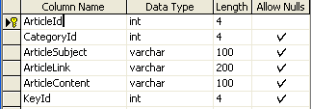

Category

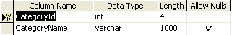

Keyword

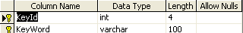

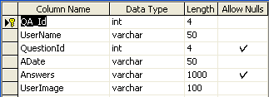

Question

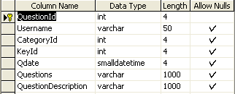

Users

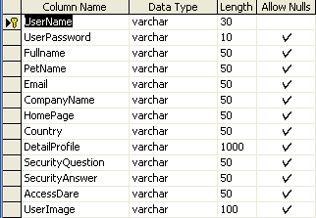

  - FRONT END DESIGN

Features Of Asp.Net

ASP.NET is the next version of Active Server Pages (ASP); it is a unified Web development platform that provides the services necessary for developers to build enterprise-class Web applications. While ASP.NET is largely syntax compatible, it also provides a new programming model and infrastructure for more secure, scalable, and stable applications.
ASP.NET is a compiled, NET-based environment, we can author applications in any .NET compatible language, including Visual Basic .NET, C#, and JScript .NET. Additionally, the entire .NET Framework is available to any ASP.NET application. Developers can easily access the benefits of these technologies, which include the managed common language runtime environment (CLR), type safety, inheritance, and so on.
ASP.NET has been designed to work seamlessly with WYSIWYG HTML editors and other programming tools, including Microsoft Visual Studio .NET. Not only does this make Web development easier, but it also provides all the benefits that these tools have to offer, including a GUI that developers can use to drop server controls onto a Web page and fully integrated debugging support.

Developers can choose from the following two features when creating an ASP.NET application. Web Forms and Web services, or combine these in any way they see fit. Each is supported by the same infrastructure that allows you to use authentication schemes, cache frequently used data, or customize your application's configuration, to name only a few possibilities.
Web Forms allows us to build powerful forms-based Web pages. When building these pages, we can use ASP.NET server controls to create common UI elements, and program them for common tasks. These controls allow we to rapidly build a Web Form out of reusable built-in or custom components, simplifying the code of a page.

An XML Web service provides the means to access server functionality remotely. Using Web services, businesses can expose programmatic interfaces to their data or business logic, which in turn can be obtained and manipulated by client and server applications. XML Web services enable the exchange of data in client-server or server-server scenarios, using standards like HTTP and XML messaging to move data across firewalls. XML Web services are not tied to a particular component technology or object-calling convention. As a result, programs written in any language, using any component model, and running on any operating system can access XML Web services

Each of these models can take full advantage of all ASP.NET features, as well as the power of the .NET Framework and .NET Framework common language runtime. Accessing databases from ASP.NET applications is an often-used technique for displaying data to Web site visitors. ASP.NET makes it easier than ever to access databases for this purpose. It also allows us to manage the database from your code .

ASP.NET provides a simple model that enables Web developers to write logic that runs at the application level. Developers can write this code in the global.aspx text file or in a compiled class deployed as an assembly. This logic can include application-level events, but developers can easily extend this model to suit the needs of their Web application.

ASP.NET provides easy-to-use application and session-state facilities that are familiar to ASP developers and are readily compatible with all other .NET Framework APIs.ASP.NET offers the IHttpHandler and IHttpModule interfaces. Implementing the IHttpHandler interface gives you a means of interacting with the low-level request and response services of the IIS Web server and provides functionality much like ISAPI extensions, but with a simpler programming model. Implementing the IHttpModule interface allows you to include custom events that participate in every request made to your application.

ASP.NET takes advantage of performance enhancements found in the .NET Framework and common language runtime. Additionally, it has been designed to offer significant performance improvements over ASP and other Web development platforms. All ASP.NET code is compiled, rather than interpreted, which allows early binding, strong typing, and just-in-time (JIT) compilation to native code, to name only a few of its benefits. ASP.NET is also easily factorable, meaning that developers can remove modules (a session module, for instance) that are not relevant to the application they are developing.

ASP.NET provides extensive caching services (both built-in services and caching APIs). ASP.NET also ships with performance counters that developers and system administrators can monitor to test new applications and gather metrics on existing applications. Writing custom debug statements to your Web page can help immensely in troubleshooting your application's code. However, it can cause embarrassment if it is not removed. The problem is that removing the debug statements from your pages when your application is ready to be ported to a production server can require significant effort.

ASP.NET offers the Trace Context class, which allows us to write custom debug statements to our pages as we develop them. They appear only when you have enabled tracing for a page or entire application. Enabling tracing also appends details about a request to the page, or, if you so specify, to a custom trace viewer that is stored in the root directory of your application. The .NET Framework and ASP.NET provide default authorization and authentication schemes for Web applications. we can easily remove, add to, or replace these schemes, depending upon the needs of our application .

ASP.NET configuration settings are stored in XML-based files, which are human readable and writable. Each of our applications can have a distinct configuration file and we can extend the configuration scheme to suit our requirements.

Visual Basic .NET, Visual C++ .NET, and Visual C# .NET all use the same integrated development environment (IDE), which allows them to share tools and facilitates in the creation of mixed-language solutions.

In addition, these languages leverage the functionality of the .NET Framework and simplify the development of ASP Web applications and XML Web services. Visual Studio supports the .NET Framework, which provides a common language runtime and unified programming classes; ASP.NET uses these components to create ASP Web applications and XML Web services. Also it includes MSDN Library, which contains all the documentation for these development tools.

THE .NET FRAMEWORK:
The .NET Framework is a new computing platform that simplifies application development in the highly distributed environment of the Internet.

6.6 BACK END DESIGN

6.6.1 SQL-SERVER 2000

The OLAP Services feature available in SQL Server version 7.0 is now called SQL Server 2000 Analysis Services. The term OLAP Services has been replaced with the term Analysis Services. Analysis Services also includes a new data mining component. The Repository component available in SQL Server version 7.0 is now called Microsoft SQL Server 2000 Meta Data Services.. The term repository is used only in reference to the repository engine within Meta Data Service
SQL-SERVER database consist of six type of objects,
They are,
1. TABLE
2. QUERY
3. FORM
4. REPORT
5. MACRO
TABLE:
A database is a collection of data about a specific topic.
VIEWS OF TABLE:
We can work with a table in two types,
1. Design View
2. Datasheet View

Design View
To build or modify the structure of a table we work in the table design view. We can specify what kind of data will be hold.
Datasheet View
To add, edit or analyses the data itself we work in tables datasheet view mode.
QUERY:
A query is a question that has to be asked the data. Access gathers data that answers the question from one or more table. The data that make up the answer is either dataset (if you edit it) or a snapshot (it cannot be edited).Each time we run query, we get latest information in the dataset. Access either displays the dataset or snapshot for us to view or perform an action on it, such as deleting or updating.
FORMS:
A form is used to view and edit information in the database record by record .A form displays only the information we want to see in the way we want to see it. Forms use the familiar controls such as textboxes and checkboxes. This makes viewing and entering data easy.

Views of Form:
We can work with forms in several primarily there are two views,
They are,
1. Design View
2. Form View

Design View

To build or modify the structure of a form, we work in forms design view. We can add control to the form that are bound to fields in a table or query, includes textboxes, option buttons, graphs and pictures.

Form View

The form view which display the whole design of the form.

REPORT:

A report is used to vies and print information from the database. The report can ground records into many levels and compute totals and average by checking values from many records at once. Also the report is attractive and distinctive because we have control over the size and appearance of it

MACRO:
A macro is a set of actions. Each action in macros does something. Such as opening a form or printing a report .We write macros to automate the common tasks the work easy and save the time.

MODULE:
Modules are units of code written in access basic language. We can write and use module to automate and customize the database in very sophisticated ways.It is a personal computer based RDBMS. This provides most of the features available in the high-end RDBMS products like Oracle, Sybase, and Ingress etc.

  - Algorithm
- In this first form has user name and password if the user enter the username and password correctly it enter to the next page.
- In this second form you must create user registration.
- After the creating the ask a question and the other user ask a question to view.
- And then next form to use in post answers.
- In this last form status is view the answers.

CHAPTER 7
CODING
Homepage.aspx

namespace YK5_Forum.Home
{
/// <summary>
/// Summary description for Home.
/// </summary>
public class Home : System.Web.UI.Page
{
protected System.Web.UI.WebControls.LinkButton LnkUpload;
protected System.Web.UI.WebControls.LinkButton lnkDownload;

private void Page_Load(object sender, System.EventArgs e)
{
string UserName=Convert.ToString (Session["UserName"]);
Session["UserName"]=UserName;

}

#region Web Form Designer generated code
override protected void OnInit(EventArgs e)
{
//
// CODEGEN: This call is required by the ASP.NET Web Form Designer.
//
InitializeComponent();
base.OnInit(e);
}

/// <summary>
/// Required method for Designer support - do not modify
/// the contents of this method with the code editor.
/// </summary>
private void InitializeComponent()
{
this.LnkUpload.Click += new System.EventHandler(this.LinkButton1_Click);
this.lnkDownload.Click += new System.EventHandler(this.lnkDownload_Click);
this.Load += new System.EventHandler(this.Page_Load);

}
#endregion

private void lnkDownload_Click(object sender, System.EventArgs e)
{
Response.Redirect("../Articles/DownLoadArticle.aspx");

}

private void LinkButton1_Click(object sender, System.EventArgs e)
{
Response.Redirect("../Articles/UploadArticle.aspx");

}

}
}

Download Article.aspx

namespace YK5_Forum.Answers.Articles
{
/// <summary>
/// Summary description for DownLoadArticle.
/// </summary>
public class DownLoadArticle : System.Web.UI.Page
{
private void Page_Load(object sender, System.EventArgs e)
{
// Put user code to initialize the page here
}

#region Web Form Designer generated code
override protected void OnInit(EventArgs e)
{
//
// CODEGEN: This call is required by the ASP.NET Web Form Designer.
//
InitializeComponent();
base.OnInit(e);
}

/// <summary>
/// Required method for Designer support - do not modify
/// the contents of this method with the code editor.
/// </summary>
private void InitializeComponent()
{
this.Load += new System.EventHandler(this.Page_Load);

}
#endregion
}
}

User Login.aspx

public class UserLogin : System.Web.UI.Page
{
protected System.Web.UI.WebControls.TextBox TextBox1;
protected System.Web.UI.WebControls.TextBox TextBox2;
protected System.Web.UI.WebControls.Button Button1;
protected System.Web.UI.WebControls.HyperLink HyperLink1;
protected System.Web.UI.WebControls.HyperLink HyperLink2;
protected System.Web.UI.WebControls.Label Label1;
protected System.Web.UI.WebControls.Label Label2;

general g = new general();

private void Page_Load(object sender, System.EventArgs e)
{
Session["UserName"]=TextBox1.Text;

}

#region Web Form Designer generated code
override protected void OnInit(EventArgs e)
{
//
// CODEGEN: This call is required by the ASP.NET Web Form Designer.
//
InitializeComponent();
base.OnInit(e);
}

/// <summary>
/// Required method for Designer support - do not modify
/// the contents of this method with the code editor.
/// </summary>
private void InitializeComponent()
{
this.Button1.Click += new System.EventHandler(this.Button1_Click);
this.Load += new System.EventHandler(this.Page_Load);

}
#endregion

private void Button1_Click(object sender, System.EventArgs e)
{

string ss="select count(username) from users where username='"+ TextBox1.Text +"' and userpassword='"+ TextBox2.Text +"' ";
if(g.scalar(ss))
{
string ss1="select DATEDIFF(day,Accessdare,getdate())from users where username='"+ TextBox1.Text +"'";
if(g.dayscheck(ss1,TextBox1.Text))
{

Session["UserName"]=TextBox1.Text;
Response.Redirect("../PostQuestions/AskQuestions.aspx");
}
else
{
Label2.Text="your Login Expired";
Label2.Visible=true;
}
}
else
{
Label2.Text="Login Failed";
Label2.Visible=true;
}

}

}
}

New User Register.aspx

general g=new general();

private void Page_Load(object sender, System.EventArgs e)
{
// Put user code to initialize the page here
//!Add Items for drQuestions
if (!Page.IsPostBack)
{
drQuestions.Items.Add("Select");
drQuestions.Items.Add("What is Your PetName");
drQuestions.Items.Add("Who is Your First Class Teacher");
drQuestions.Items.Add("Who is Your Role Model");
drQuestions.Items.Add("What is your Favorite dish");
drQuestions.Items.Add("What is your Favorite color");
}

}

#region Web Form Designer generated code
override protected void OnInit(EventArgs e)
{
//
// CODEGEN: This call is required by the ASP.NET Web Form Designer.
//
InitializeComponent();
base.OnInit(e);
}

/// <summary>
/// Required method for Designer support - do not modify
/// the contents of this method with the code editor.
/// </summary>
private void InitializeComponent()
{
this.Button2.Click += new System.EventHandler(this.Button2_Click);
this.Load += new System.EventHandler(this.Page_Load);

}
#endregion

private void Button2_Click(object sender, System.EventArgs e)
{
string image="Null";
string AccessDare=Convert.ToString(DateTime.Now.ToShortDateString());
g.insert("insert into users values('"+ txtusername.Text +"','"+ txtpwd.Text +"','"+ txtfullname.Text +"','"+txtPetName.Text+"','"+ txtemail.Text +"','"+ txtcompany.Text +"','"+ txthomepage.Text +"','"+drcountry.SelectedItem.Text +"','"+ txtdetailedprofile.Text +"','"+drQuestions.SelectedItem.Text+"','"+txtSecurityAnswer.Text+"','"+AccessDare+"','"+ image +"')");
Session["username"]=txtusername.Text;
Response.Redirect("MyAccount.aspx");

}

private void Button4_Click(object sender, System.EventArgs e)
{

}

}
}

Edit profile.aspx

public SqlConnection con = new SqlConnection("server=.;database=YK5_Forum;uid=sa;");

private void Page_Load(object sender, System.EventArgs e)
{
string un=Convert.ToString(Session["UserName"]);
if (!Page.IsPostBack)
{
drQuestions.Items.Add("Select");
drQuestions.Items.Add("What is Your PetName");
drQuestions.Items.Add("Who is Your First Class Teacher");
drQuestions.Items.Add("Who is Your Role Model");
drQuestions.Items.Add("What is your Favorite dish");
drQuestions.Items.Add("What is your Favorite color");
con.Open();
SqlCommand cmd = new SqlCommand("select * from users where username='"+un+"'",con);
SqlDataReader dr;
dr=cmd.ExecuteReader();
if(dr.Read())
{
txtusername.Text=dr[0].ToString();
txtfullname.Text=dr[2].ToString();
txtPetName.Text=dr[3].ToString();
txtemail.Text=dr[4].ToString();
txtcompany.Text=dr[5].ToString();
txthomepage.Text=dr[6].ToString();
drcountry.SelectedItem.Text=dr[7].ToString();
drQuestions.SelectedItem.Text=dr[9].ToString();
txtSecurityAnswer.Text=dr[10].ToString();
}
con.Close();
}
}

#region Web Form Designer generated code
override protected void OnInit(EventArgs e)
{
//
// CODEGEN: This call is required by the ASP.NET Web Form Designer.
//
InitializeComponent();
base.OnInit(e);
}

/// <summary>
/// Required method for Designer support - do not modify
/// the contents of this method with the code editor.
/// </summary>
private void InitializeComponent()
{
this.Button2.Click += new System.EventHandler(this.Button2_Click);
this.Button3.Click += new System.EventHandler(this.Button3_Click);
this.Load += new System.EventHandler(this.Page_Load);

}
#endregion

private void Button2_Click(object sender, System.EventArgs e)
{
string un=Convert.ToString(Session["username"]);
g.insert("update users set UserName='"+ txtusername.Text +"',Fullname='"+ txtfullname.Text +"',PetName='"+ txtPetName.Text +"',Email='"+ txtemail.Text +"',CompanyName='"+ txtcompany.Text +"',HomePage='"+ txthomepage.Text +"',Country='"+ drcountry.SelectedItem.Text +"',securityquestion='"+ drQuestions.SelectedItem.Text +"',securityanswer='"+ txtSecurityAnswer.Text +"' where UserName='"+ un +"'");
Label2.Text="Profile Updated";
Label2.Visible=true;
txtusername.Text="";
txtfullname.Text="";
txtPetName.Text="";
txtemail.Text="";
txtcompany.Text="";
txthomepage.Text="";
drcountry.SelectedItem.Text="";
drQuestions.SelectedItem.Text="";
txtSecurityAnswer.Text="";
Session["username"]=un;
}

private void Button3_Click(object sender, System.EventArgs e)
{
Response.Redirect("EditProfile.aspx");
}
}
}

Post question.aspx

public class AskQuestions : System.Web.UI.Page
{
protected System.Web.UI.WebControls.Image Image1;
protected System.Web.UI.WebControls.Label lblCategoryId;
protected System.Web.UI.WebControls.TextBox txt_Q_Title;
protected System.Web.UI.WebControls.TextBox txt_Q_Subject;
protected System.Web.UI.WebControls.TextBox txt_Q_Description;
protected System.Web.UI.WebControls.Button btnSubmit;
general g=new general();
private void Page_Load(object sender, System.EventArgs e)
{
string id;
id=Request.QueryString["id"];
lblCategoryId.Text=id;
if(!Page.IsPostBack)
{
string UserName=Convert.ToString(Session["UserName"]);
if(g.scalar("select count(UserName) from Users where UserName='"+UserName+"'"))
{

}
else
{
Response.Redirect("../NewUser/UserLogin.aspx");
}
Session["UserName"]=UserName;
}

}

#region Web Form Designer generated code
override protected void OnInit(EventArgs e)
{
//
// CODEGEN: This call is required by the ASP.NET Web Form Designer.
//
InitializeComponent();
base.OnInit(e);
}

/// <summary>
/// Required method for Designer support - do not modify
/// the contents of this method with the code editor.
/// </summary>
private void InitializeComponent()
{
this.btnSubmit.Click += new System.EventHandler(this.btnSubmit_Click);
this.Load += new System.EventHandler(this.Page_Load);

}
#endregion

private void LinkButton2_Click(object sender, System.EventArgs e)
{

}

private void btnSubmit_Click(object sender, System.EventArgs e)
{
string UserName=Convert.ToString(Session["UserName"]);
string Qdate;
int Category;
Category=Convert.ToInt32(Request.QueryString["id"]);
Qdate=Convert.ToString(DateTime.Now.ToShortDateString());
g.insert("insert into KeyWord values('"+txt_Q_Subject.Text+"')");
string Key=g.ReturnString("select KeyId from Keyword where Keyword='"+txt_Q_Subject.Text+"'");
g.insert("insert into Question values('"+UserName+"',"+Category+",'"+Key+"','"+Qdate+"','"+txt_Q_Title.Text+"','"+txt_Q_Description.Text+"')");

Response.Redirect("../PostQuestions/UserView.aspx");
}

private void LinkButton1_Click(object sender, System.EventArgs e)
{

}

private void Button1_Click(object sender, System.EventArgs e)
{

}
}
}

Search .aspx.

private void LinkButton1_Click(object sender, System.EventArgs e)
{
txtarticle.Visible=true;
btarticle.Visible=true;
txtqa.Visible=false;
btqa.Visible=false;
}

private void LinkButton2_Click(object sender, System.EventArgs e)
{
txtarticle.Visible=false;
btarticle.Visible=false;
txtqa.Visible=true;
btqa.Visible=true;
}

private void btarticle_Click(object sender, System.EventArgs e)
{
string sql="select keyid from keyword WHERE KeyWord like '%"+txtarticle.Text+"%'";
int k;
k=Convert.ToInt32(g.Returnvalue(sql));

g.viewList("SELECT * FROM article WHERE KeyId="+ k +" ",DataList1);

}

private void btqa_Click(object sender, System.EventArgs e)
{
string sql="select keyid from keyword WHERE KeyWord like '%"+txtqa.Text+"%'";
int k;
int YN;
k=Convert.ToInt32(g.Returnvalue(sql));

SqlConnection con = new SqlConnection("server=.;database=YK5_Forum;uid=sa;");
YN=g.Returnvalue("SELECT * FROM Question WHERE keyid="+ k +"");
if(YN==1)
{
SqlDataAdapter adp=new SqlDataAdapter("SELECT * FROM Question WHERE keyid="+ k +"",con);
DataSet ds=new DataSet();
adp.Fill(ds);
Datalist2.DataSource=ds;
Datalist2.DataBind();
}
else
{
lblMsg.Text="Searching Item Not Found Give More Information!";
}

}

Userview.aspx

public int k;
private void Page_Load(object sender, System.EventArgs e)
{
// Put user code to initialize the page here

k=g.Returnvalue("select top 1 QuestionId from Question order by QuestionId desc");

if(!Page.IsPostBack)
{
g.viewList("Select * from Question where QuestionId="+k+"",DataList1);
}
}
#region Web Form Designer generated code
override protected void OnInit(EventArgs e)
{
//
// CODEGEN: This call is required by the ASP.NET Web Form Designer.
//
InitializeComponent();
base.OnInit(e);
}

/// <summary>
/// Required method for Designer support - do not modify
/// the contents of this method with the code editor.
/// </summary>
private void InitializeComponent()
{
this.Button1.Click += new System.EventHandler(this.Button1_Click);
this.Button3.Click += new System.EventHandler(this.Button3_Click);
this.Button2.Click += new System.EventHandler(this.Button2_Click);
this.Load += new System.EventHandler(this.Page_Load);

}
#endregion

private void Button1_Click(object sender, System.EventArgs e)
{
g.viewList("Select* from Question where QuestionId="+k+" ",DataList2);
Panel1.Visible=true;
g.viewList("Select* from Question where QuestionId="+k+" ",DataList1);

}

private void Button2_Click(object sender, System.EventArgs e)
{
g.insert("Update Question set Questions='"+txtAddInformation.Text+"' where QuestionId="+k+" ");
lblMsg.Text="Edit Successfully";
}

private void Button3_Click(object sender, System.EventArgs e)
{
Response.Redirect("../Home/Home.aspx");
}
}
}

CHAPTER 8
SYSTEM TESTING

8.1 Unit Testing

The procedure level testing is made first. By giving improper inputs, the errors occurred are noted and eliminated. Then the web form level testing is made. For example storage of data to the table in the correct manner.

The dates are entered in wrong manner and checked. Wrong email-id and web site URL (Universal Resource Locator) is given and checked.

8.2 Integration Testing

Testing is done for each module. After testing all the modules, the modules are integrated and testing of the final system is done with the test data, specially designed to show that the system will operate successfully in all its aspects conditions. Thus the system testing is a confirmation that all is correct and an opportunity to show the user that the system works.

8.3 Validation Testing

The final step involves Validation testing, which determines whether the software function as the user expected. The end-user rather than the system developer conduct this test most software developers as a process called “Alpha and Beta Testing” to uncover that only the end user seems able to find.

The compilation of the entire project is based on the full satisfaction of the end users. In the project, validation testing is made in various forms. In registration form Email id, phone number and also mandatory fields for the user is verified.

8.4 Verification Testing

Verification is a fundamental concept in software design. This is the bridge between customer requirements and an implementation that satisfies those requirements.
This is verifiable if it can be demonstrated that the testing will result in an implementation that satisfies the customer requirements.

Inadequate testing or non-testing leads to errors that may appear few months later. This will create two problems

- Time delay between the cause and appearance of the problem.
- The effect of the system errors on files and records within the system.
Maintenance

The objectives of this maintenance work are to make sure that the system gets into work all time without any bug. Provision must be for environmental changes which may affect the computer or software system. This is called the maintenance of the system. Nowadays there is the rapid change in the software world. Due to this rapid change, the system should be capable of adapting these changes. In our project the process can be added without affecting other parts of the system.

8.5 User Acceptance Testing

User acceptance testing of a system is the key factor of the success of any system. The system under study is tested for the user acceptance by constantly keeping in touch with the prospective system users at any time of developing and making changes whenever required.

CHAPTER 9

PROBLEMS FACED

When there is a clear goal in sight but no clear set of directions or means to attain that goal, then it is called a problem. problems can be broken down into four aspects; goal, givens, means of transforming conditions, and obstacles.
Goal – the goal is the desired end state which the problem solving is being directed toward.
The hope is to reach that end state and be able to assess whether or not you achieved what you wanted.
Givens- these are the objects , conditions ,and constraints that accompany a problem ,and can be either explicit or implicit.
Means of transforming conditions- there should be a way of changing the initial stateof the problem.this is most usually a person’s knowledge or skill level. For instance ,a computer programmer presented with a problem would utilize his or her knowledge of programming language to transform the state of the problem.
Obstacles- the problem should present a challenge.if there are no challenges involved and the situation can be easily solved then it is not so a problem so much as a rountine task.
Every problem has a problem faced, which is the whole range of possible states and operators.only some of these states and operators will bring the person closer to the goal state. The problem starts at the initial state and operators are applied to change the state, creating a series of intermediate states that should hopefully lead to the final goal state

CHAPTER 10

FUTURE PLANS

Every application has its own merits and demerits. The project has covered almost all the requirements. Further requirements and improvements can easily be done since the coding is mainly structured or modular in nature.
Changing the existing modules or adding new modules can append improvements. Further enhancements can be made to the application, so that the web site functions very attractive and useful manner than the presents.

CONCLUSION

It is concluded that the application works well and satisfy the both registered and registered. The application is tested very well and errors are properly debugged. The site is simultaneously accessed from more than one system.

The site works according to the restrictions provided in their respective browsers. The speed of the transactions become more enough now. In this site the user can search the appropriate answers for their questions.. They can view their favorable questions, articles and inventions.

APPENDIX

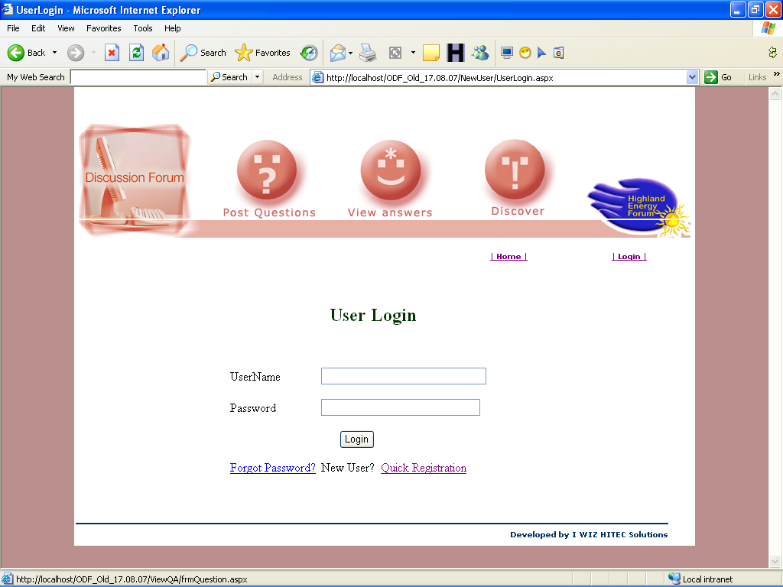

Fig 1.Login

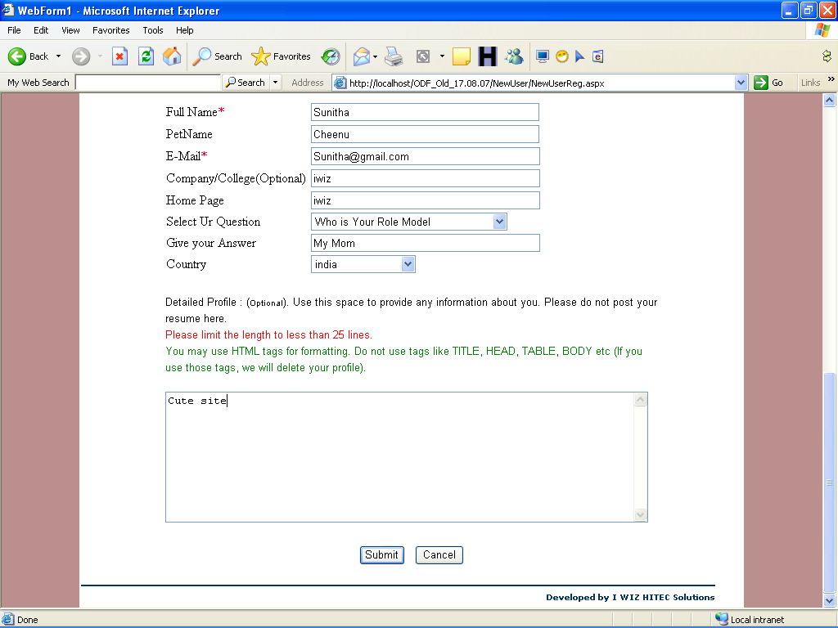

Fig.2 Register

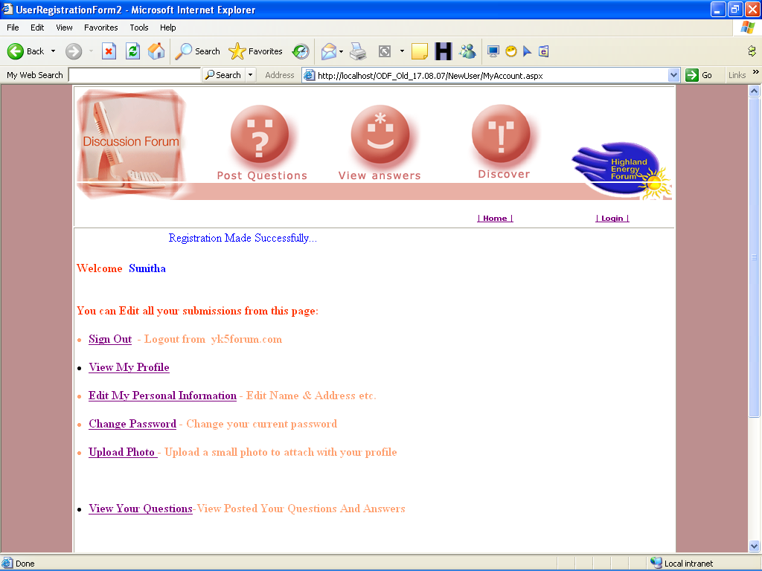

Fig 3. Registration Completed

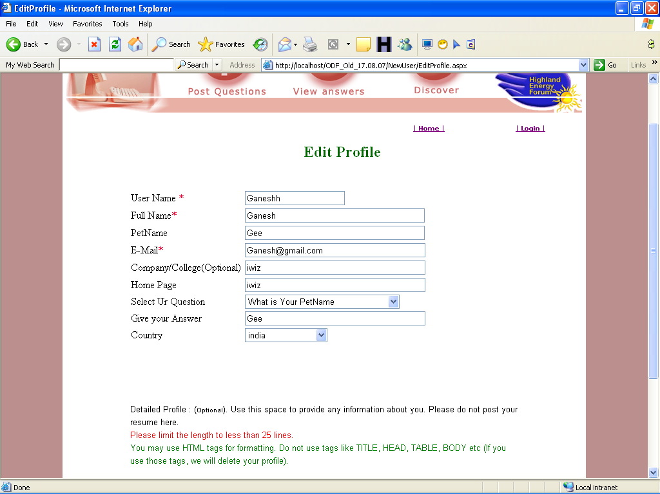

Fig 4. Edit Profile

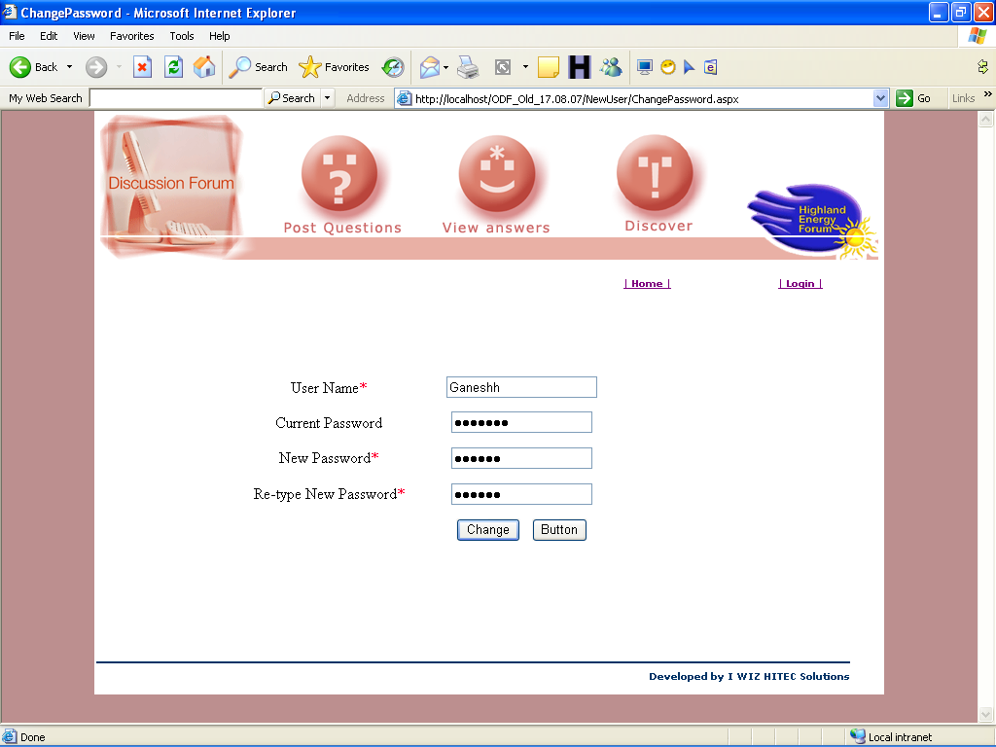

Fig 5. Change Password

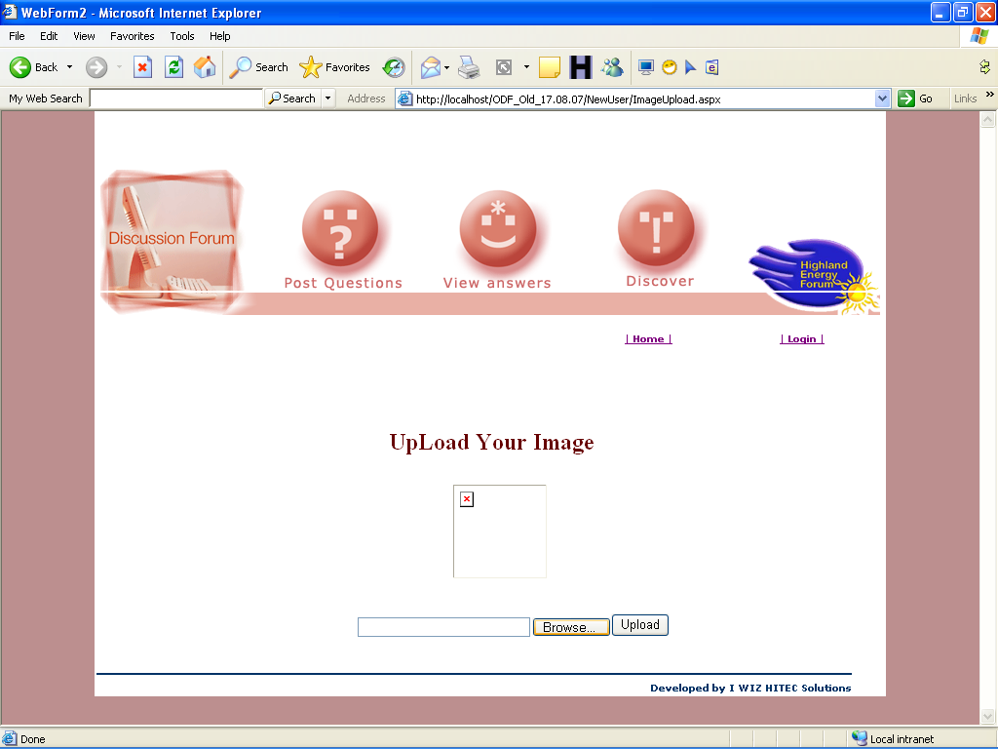

Fig 6. Upload Image

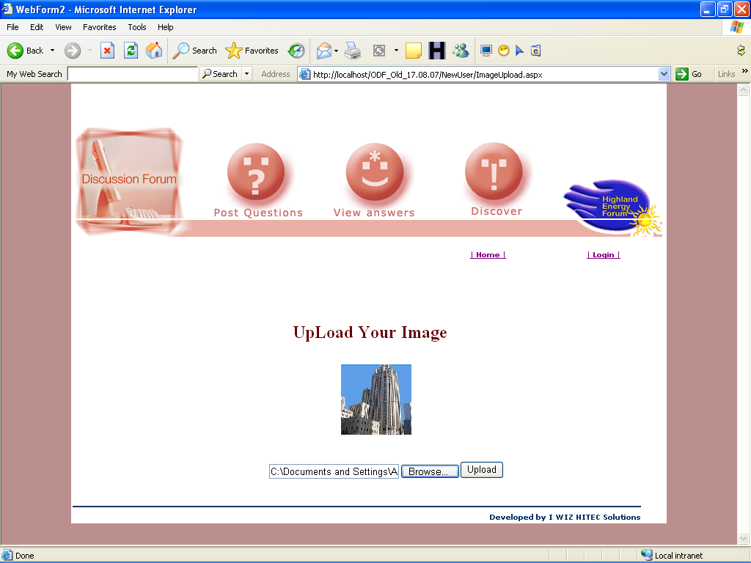

Fig 6. Upload Image Successfully

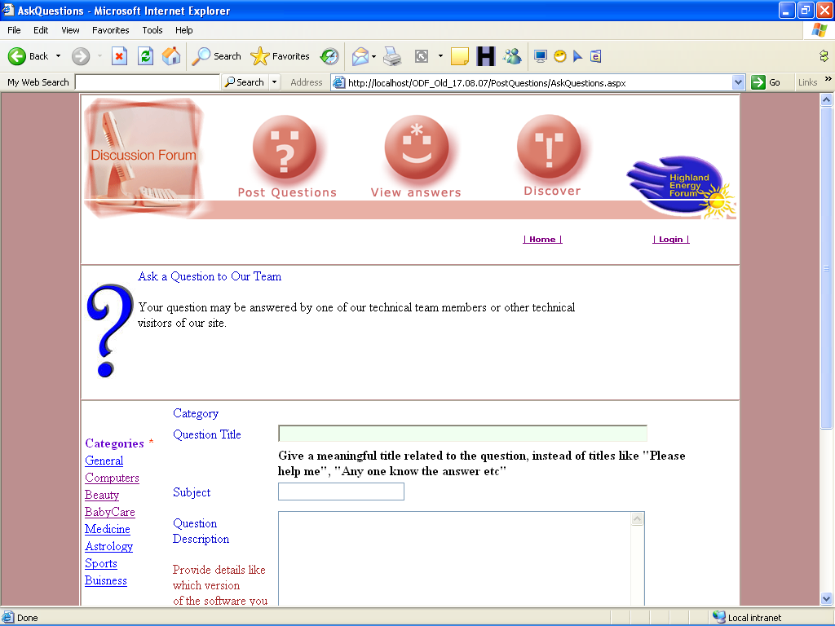

Fig 7. Ask a Question

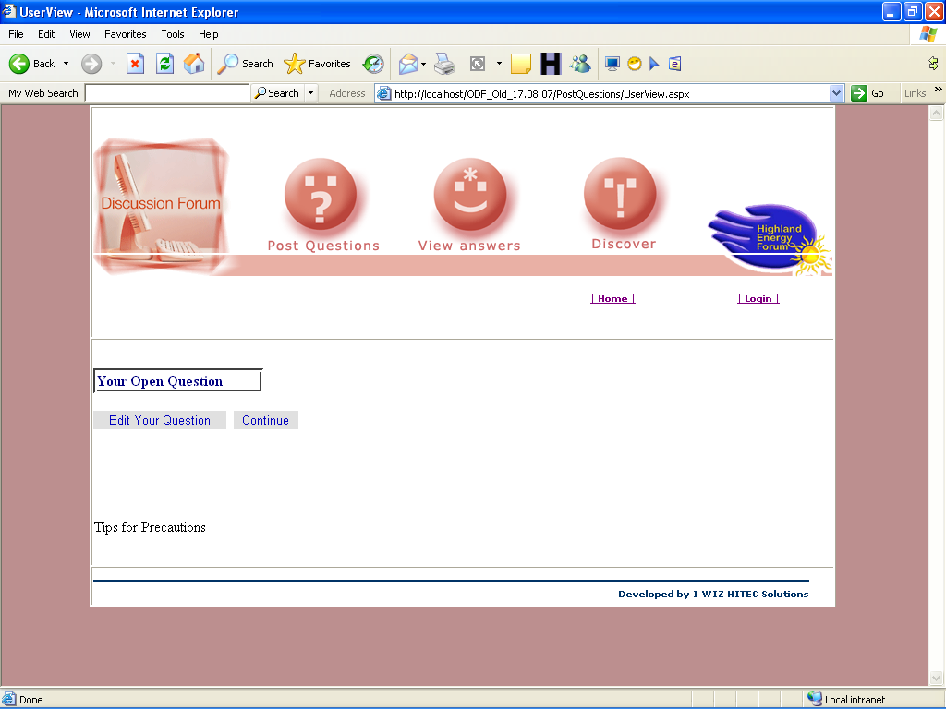

Fig 8. View Question

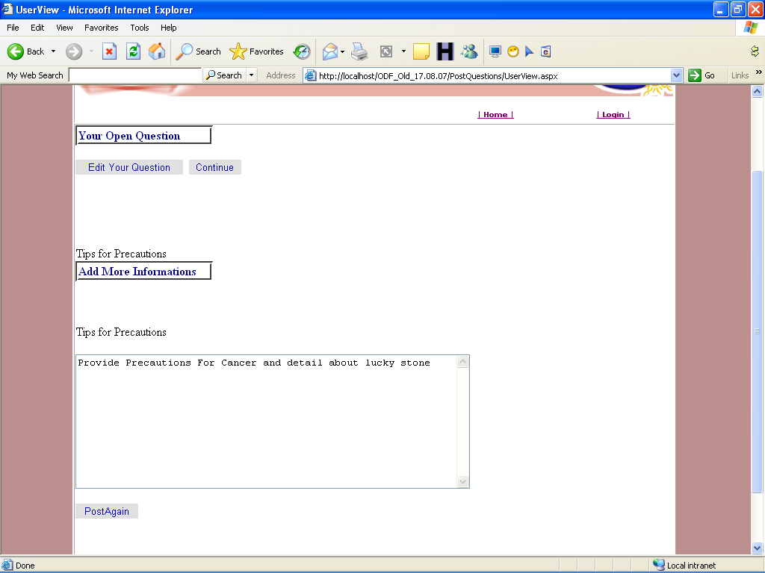

Fig 9. Add Question

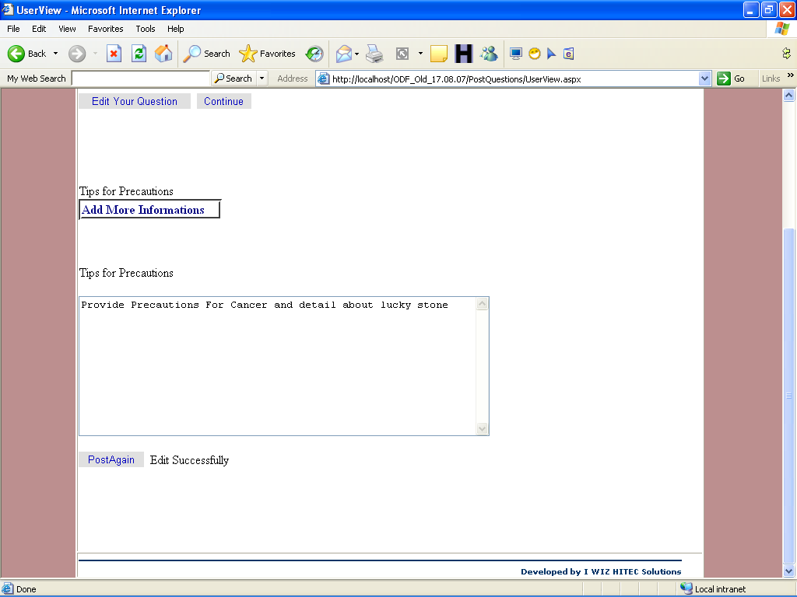

Fig 10. Edit Question

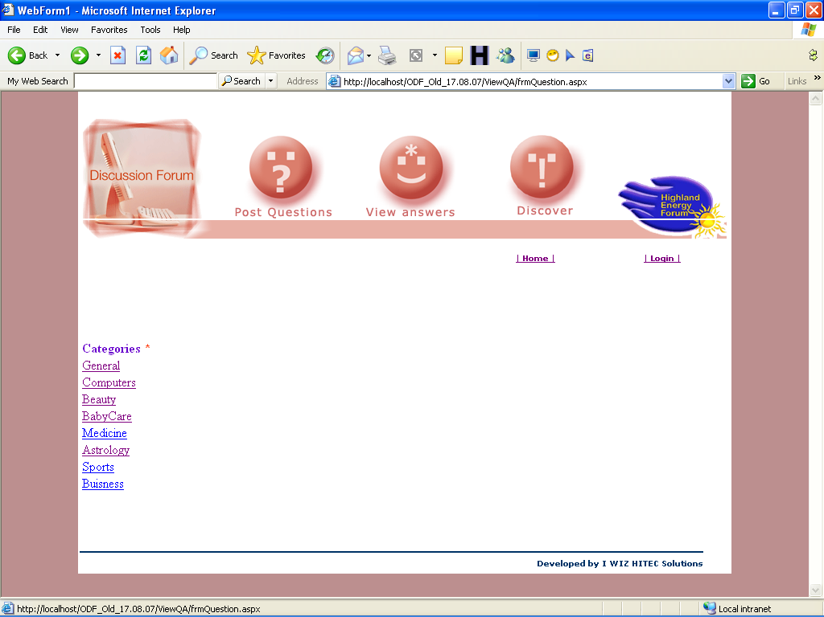

Fig 11. View Categories

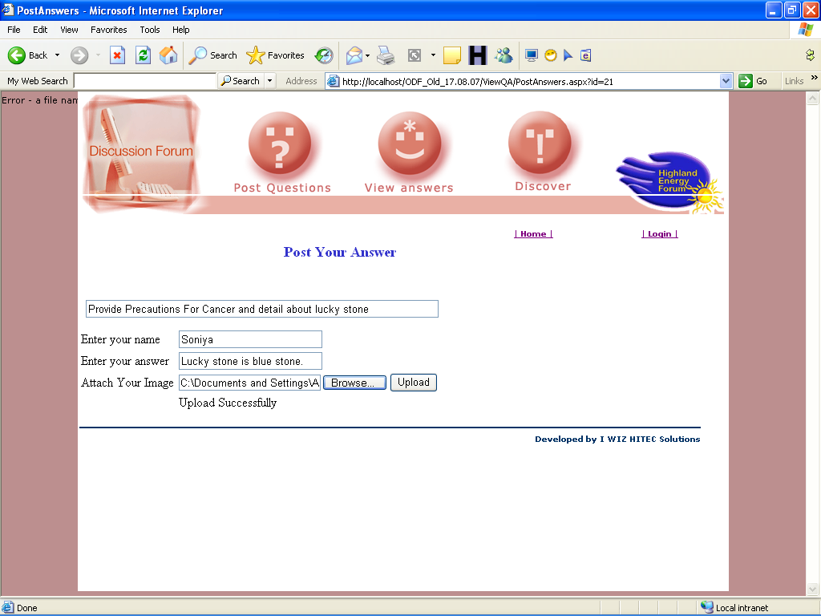

Fig 12. Post Answers

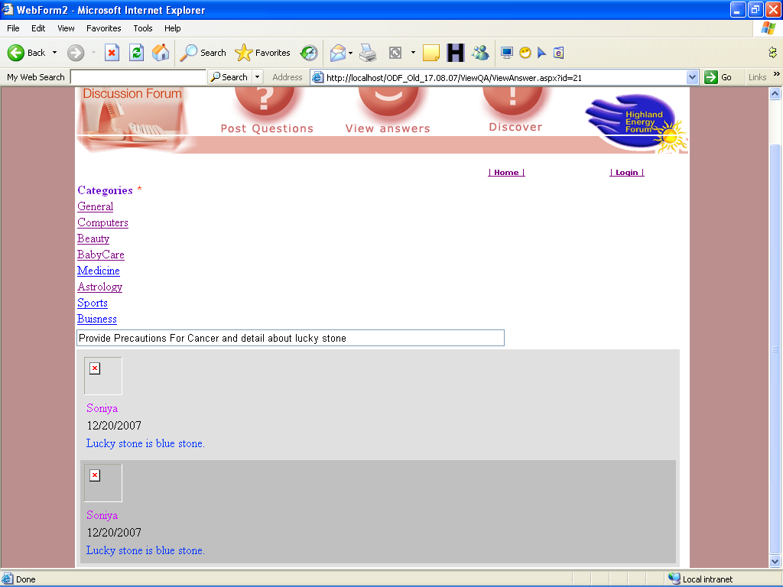

Fig 13. View Answers

REFERENCES

- STEVE HARRIS AND ROBMACDONALD,
“WEB DEVELOPMENT WITH VB.NET”

-APRES

- MATTHEW MACDONALD ,
“MICROSOFT VISUAL BASIC.NET PROGRAMMER’S COOKBOOK”

-TATA McGraw HILL EDITION

3. CHRIS GOODE, JOHN KAUFFMAN
“BEGINNING ASP.NET 1.0 WITH VISUAL BASIC.NET”

-WROX PROGRAMMER TO PROGRAMMER

4. Douglas O.Reilly,
“DESIGNING MICROSOFT ASP.NET APPLICATIONS”

-TATA McGraw HILL EDITION

BIBLIOGRAPHY

- www.codeproject.com/KB/custom-controls/asppopup.aspx
- http://www.developerfusion.com/code/4673/programatically-load-user-controls/
- http://www.developerfusion.com/code/4596/how-to-access-a-mysql-database-with-net/
- http://www.developerfusion.com/code/3826/adding-controls-to-placeholders-dynamically/
- http://aspalliance.com/1125_Dynamically_Templated_GridView_with_Edit_Delete_and_Insert_Options
- www.codeproject.com/KB/custom-controls/asppopup.aspx
- http://www.developerfusion.com/code/4673/programatically-load-user-controls/
- http://www.developerfusion.com/code/4596/how-to-access-a-mysql-database-with-net/
- http://www.developerfusion.com/code/3826/adding-controls-to-placeholders-dynamically/
- http://aspalliance.com/1125_Dynamically_Templated_GridView_with_Edit_Delete_and_Insert_Options

